**Aim – How to fetch Azure Key Vault secrets in Azure Pipelines.**

1. Go to azure resources, create Key vault and fill all the details.
2. Now generate secrets and fill all the details.

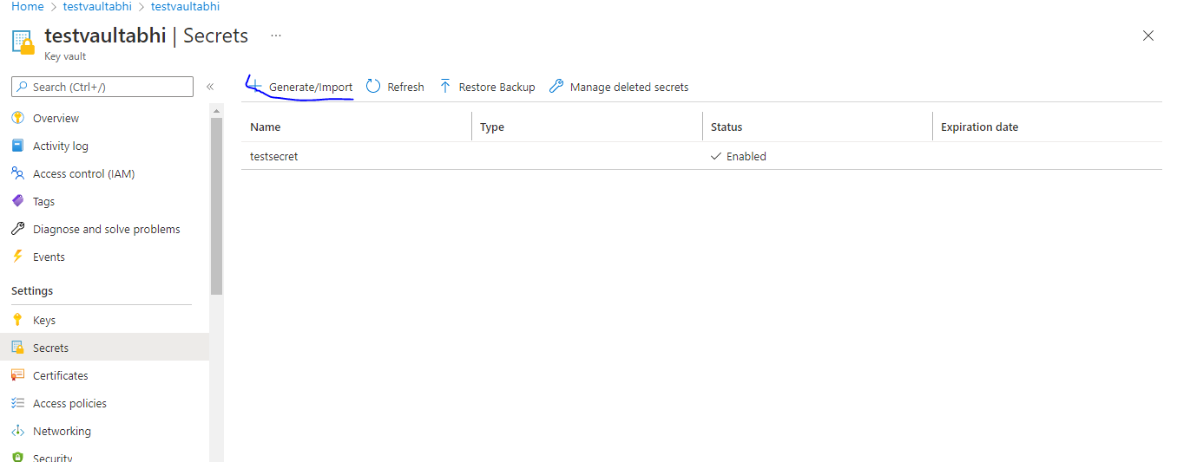

1. **Now go to Azure Devops**
   1. Go to Azure repo and create a new blank repository.
   2. Go to pipeline and select Azure Repos and that repo which you have created**. [In configure section select Starter pipeline]**
   3. **Go to the last line and in assistance section “key vault” and add in yaml and add below given lines at the end of the yaml to save your secret.**

- script: echo $(testsecret) > testsecret.txt

- publish: testsecret.txt

* 1. Run the pipeline you will get this error, now click on View and permit it.

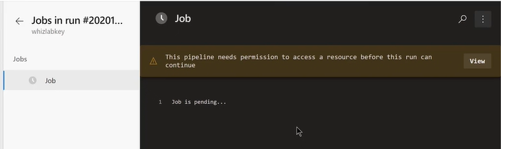

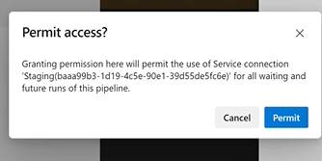

* 1. **Now again run the same job , this time it will start but at AzureKeyVault task it will get stuck because it is not having permission.**

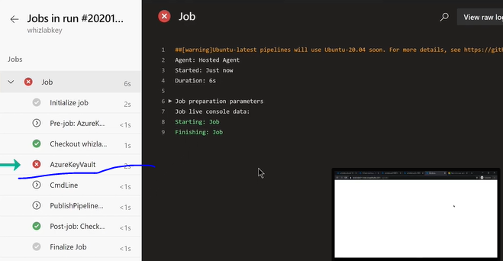

1. Now go to your Azure vault 🡪 Access Policy 🡪 Add Access Policy 🡪in Secret Management Operations give permission of (get and list) and in select principal , search your user name like consult2teamit something, you will get main account and principal account which is attached to your devops .
2. Add access policy and save .
3. Now go to pipeline and run it , go to job you will get that file under artifacts , open it you will get that.